Hospital Management System for RK Hospital

Problem Statement:

We are designing a Hospital Management System for RK Hospital. This is a small-scale Hospital with limited staff and limited number of patients, assuming that hospital does not require any kind of Data storage infrastructure like SQL or cloud, we would be working using CSV files as the required Database. you have been given two CSV files.

1. Hospital_Management.csv- Consists of Details about the patients

2) Doctor_entry.csv- Consists of Feedback from the doctor

We need to perform the following task:

1. Read the Data from the given CSV files.
2. Generating patient’s ID- To generate patients ID, we use first three letters from the patient’s name (In UPPERCASE) and concatenate it with Day and a month from the visiting Date.

(Ex. Patient name= Mathew, Visiting Date=2021-01-30, then patient ID =”MAT3001”

1. Entry to be created in the patients Database :

3.1) Creating the Token: Token would be created as per the Entry Number.

(Ex. Entry number = 46, Visit date=01-30-2021

Token number =RKC+visit_date (String format) + '00'+entryNumber,

Token number= RKC013020210046)

3.2) write a function by name “patient entry”. Use this to create the Token and add all patient Related Data to “Hospital_Management.csv”

4) Adding Doctors Comments:

4.1) write a function “doc_entry” that takes Token ID as an Input and lets the Doctor to update the Patients Data as per his Diagnosis.

4.2) Generate the prescription number

Ex: Preciption_Number=patient_id+visit_date(ddmmyyyy)

5) Creating the Patient Report:

Patient report should be in the following format:

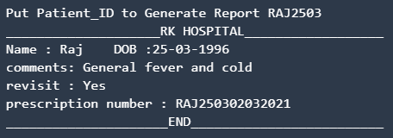

In order to run the project, you must have installed Python and on your PC. This hospital management system project is especially for beginners.